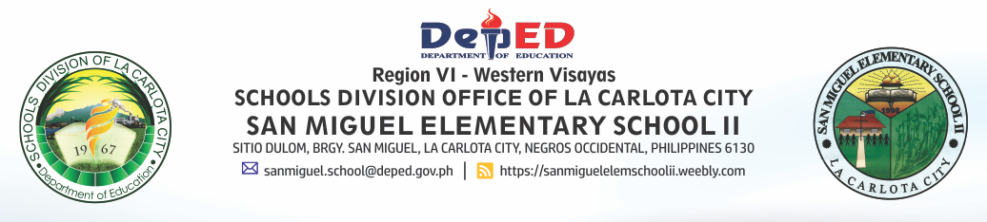

Date: July 2, 2018
School Memorandum No. _____ s. 2018
From: Office of the Principal
To: School SBM – WINS Coordinator, Teachers, Parents, and Pupils
Subject: Strengthening the SBM - WINS Implementation

- To strengthen the implementation of SBM WinS the following measures must be observed:
- Water Access
- School SBM WinS coordinator shall facilitate the regular testing of water.
- Water testing must be done every August and February or when need arises.
- School shall allot an amount from its income generating project for the payment of its water bill.
- The school shall prioritize the procurement of water dispenser from its MOOE/IGP.
- The school WInS Club shall conduct regular checking of water connections for possible leaks and take appropriate actions thereof.
- In case when water supply is temporarily cut-off due to maintenance,
- Learners are instructed to bring their own tumbler filled with water.
- Every classroom must have a water jug filled with water that is safe for drinking.
- In case when water is found unsafe for drinking based on the result of water testing,
- Homeroom PTA shall be responsible for purchasing drinking water from refilling stations.
- Teacher adviser shall take a lead in ensuring the availability of safe drinking water everyday.
- Collected rainwater shall be used for daily handwashing and cleaning of toilets.
- Sanitation
- Ensured that all classrooms have segregated toilet.
- Ensured that toilets are clean and functioning well.
- Children must be taught of proper way of using the toilet.
- No burning of waste must be strictly implemented.
- Segregation of garbage must be implemented religiously.
- Trash bins must be available around the school campus.
- Material Recovery Facility area must be functional.
- Ensured that there are no stagnant water from wash areas.
- The SBM WinS coordinator must secure sanitary permit for the school canteen.
- School feeding coordinator must ensure that food handlers have:
- Secured their health certificate.
- Oriented on food safety.
- Observed food safety measures religiously.\
- Hygiene
- Group and individual handwashing facility must be functional.
- Daily group handwashing and toothbrushing must be conducted religiously.
- Teacher adviser must ensure that every learner has hygiene kit.
- Ensured that women-friendly space is functional.
- Deworming
- Ensured that at least 85% of the learners are dewormed.
- Health Education:
- Every classroom must have a bulletin board and IEC materials on Wash in Schools Program.
- Wash In Schools Program must be included in the INSET and must be communicated to the parents during PTA meeting.
- Please be guided. Wide dissemination of this memorandum is desired.

REVILYN Y. SOLOMON
Principal I

